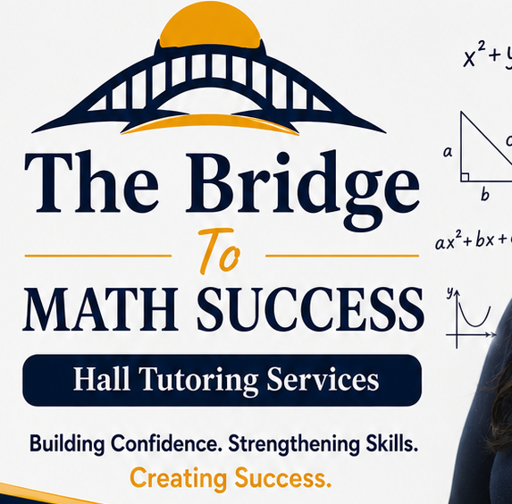
THE BRIDGE TO MATH AND CHEMISTRY SUCCESS HALL TUTORING SERVICES
STUDENT ONGOING ASSESSMENT & PROGRESS MONITORING FORM
Student Information
Student Name: ______________________________________________
Grade: ______________________________________________
School: ______________________________________________
Subject(s): ______________________________________________
Tutor: ______________________________________________
Reporting Period: ______________________________________________
Date: ______________________________________________
Current Learning Goals
Goal 1: ______________________________________________
Goal 2: ______________________________________________
Goal 3: ______________________________________________
Session Progress Log
Date | Skill/Standard | Activity | Score/Result | Participation | Homework | Tutor Feedback | Next Steps
Performance Ratings
Mathematical/Chemistry Understanding: ☐1 ☐2 ☐3 ☐4 ☐5
Problem-Solving Skills: ☐1 ☐2 ☐3 ☐4 ☐5
Confidence: ☐1 ☐2 ☐3 ☐4 ☐5
Homework Completion: ☐1 ☐2 ☐3 ☐4 ☐5
Participation & Effort: ☐1 ☐2 ☐3 ☐4 ☐5
Progress Summary
Skills Mastered:
________________________________________________________
Skills Requiring Additional Practice:
________________________________________________________
Evidence of Growth:
________________________________________________________
Parent Communication
Date: _____________________
Method: ☐ In Person ☐ Phone ☐ Email ☐ Text ☐ Written Progress Report
Summary:
________________________________________________________
Instructional Plan for Next Reporting Period
☐ Continue current plan
☐ Increase tutoring frequency
☐ Focus on prerequisite skills
☐ Test preparation
☐ Enrichment activities
☐ Reassess learning goals
Additional Notes:
________________________________________________________
Signatures
Tutor: __________________________________ Date: __________
Parent/Guardian: ________________________ Date: __________
Student: ________________________________ Date: __________

