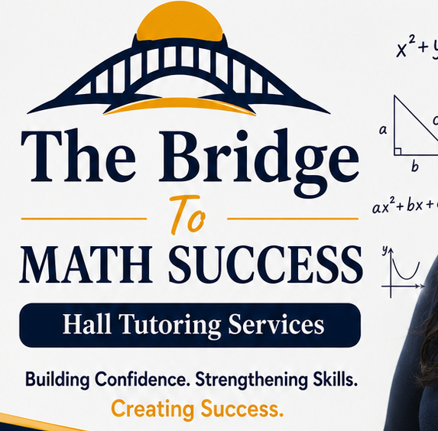
THE BRIDGE TO MATH AND CHEMISTRY SUCCESS HALL TUTORING SERVICES
ACADEMIC INTEGRITY POLICY
Purpose
The Bridge to Math and Chemistry Success Hall Tutoring Services is committed to fostering honesty, responsibility, and ethical academic behavior. This policy establishes expectations for students, parents/guardians, and tutors so that tutoring strengthens genuine learning and independent achievement.
Core Principles
- Honesty in all academic work.
- Personal responsibility for learning.
- Respect for intellectual property.
- Fairness and ethical decision-making.
- Growth through understanding rather than shortcuts.
Student Expectations
- Complete assignments using your own understanding unless collaboration is specifically authorized.
- Use tutoring sessions to learn concepts and strategies rather than obtain answers only.
- Ask questions when you need clarification.
- Properly acknowledge sources when required by a teacher or school.
- Follow all school and classroom academic integrity expectations.
Artificial Intelligence (AI) and Technology
AI tools may be used only when permitted by a student's teacher or school and only as learning aids. Students are expected to understand, verify, and be able to explain any work submitted. AI-generated responses should never be presented as original student work when prohibited by school or classroom expectations.
Tutor Responsibilities
- Teach concepts, strategies, and problem-solving skills.
- Encourage independent thinking and perseverance.
- Refuse requests to complete assignments or assessments on behalf of students.
- Provide honest feedback about student progress.
- Model ethical academic behavior at all times.
Examples of Academic Misconduct
- Copying another person's work.
- Submitting work completed primarily by someone else without authorization.
- Using unauthorized notes, calculators, websites, or AI tools during assignments or assessments.
- Plagiarism or failing to credit sources when required.
- Sharing answers intended to be completed independently.
Response to Violations
- Discuss the concern with the student.
- Notify the parent or guardian when appropriate.
- Adjust tutoring strategies to reinforce ethical learning.
- Decline assistance that would violate school or classroom rules.
- Terminate tutoring services for repeated or serious violations when necessary.
Acknowledgment
I have read, understand, and agree to follow this Academic Integrity Policy.
Student Name: __________________________________________
Student Signature: ____________________________ Date: __________
Parent/Guardian Signature: _____________________ Date: __________
Tutor Representative: __________________________ Date: __________

