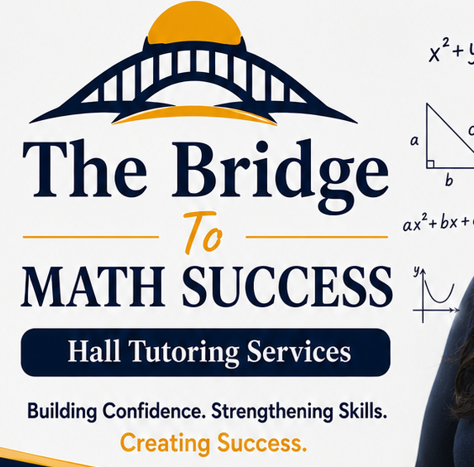
THE BRIDGE TO MATH AND CHEMISTRY SUCCESS HALL TUTORING SERVICES
CODE OF CONDUCT
Mission
We are committed to providing a safe, respectful, encouraging, and academically rigorous environment where students develop confidence and excellence in mathematics and chemistry.
Student Expectations
- Arrive on time and prepared.
- Respect tutors, staff, and peers.
- Participate actively.
- Complete assigned practice honestly.
- Use appropriate language.
- Care for facilities and materials.
- Use electronic devices only when permitted.
- Follow tutor directions.
- Maintain academic integrity.
Parent/Guardian Responsibilities
- Ensure prompt arrival and pickup.
- Communicate schedule changes promptly.
- Support regular attendance and home practice.
- Maintain respectful communication.
Tutor Responsibilities
- Provide professional, well-prepared instruction.
- Treat every student fairly and respectfully.
- Protect student confidentiality.
- Communicate progress regularly.
- Maintain a positive learning environment.
Behavior Expectations
Bullying, harassment, discrimination, profanity, intimidation, cheating, vandalism, or disruptive behavior will not be tolerated.
Attendance and Cancellations
Families should provide advance notice whenever possible if a session must be canceled or rescheduled.
Consequences
- Reminder
- Parent notification
- Behavior conference
- Temporary suspension
- Termination of tutoring services for repeated or serious violations
Acknowledgment
We have read and agree to follow this Code of Conduct.
Student: ____________________________ Date: __________
Parent/Guardian: ____________________ Date: __________
Tutor Representative: _______________ Date: __________

OUR MOTTO
“BUILDING CONFIDENCE. BRIDGING GAPS. STRENGTHENING SKILLS. CREATING SUCCESS”

