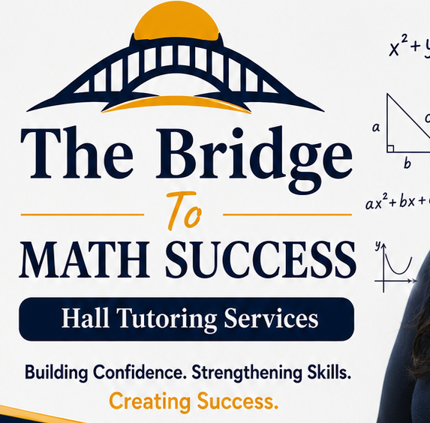
THE BRIDGE TO MATH AND CHEMISTRY SUCCESS HALL TUTORING SERVICES
LIABILITY WAIVER AND RELEASE AGREEMENT
Student Information
Student Name: ______________________________________________
Date of Birth: ______________________________________________
Grade: ______________________________________________
School: ______________________________________________
Parent/Guardian Name: ______________________________________________
Primary Phone: ______________________________________________
Email: ______________________________________________
Acknowledgment of Tutoring Services
I understand that The Bridge to Math and Chemistry Success Hall Tutoring Services provides educational tutoring and academic support. Tutoring is intended to improve understanding and academic skills but does not guarantee specific grades, test scores, admissions decisions, or other educational outcomes.
Assumption of Responsibility
I understand that the student's academic progress depends on attendance, participation, effort, completion of assigned practice, communication with teachers, and other factors beyond the tutoring service's control.
Release of Liability
To the extent permitted by applicable law, I release and hold harmless The Bridge to Math and Chemistry Success Hall Tutoring Services, its owners, employees, and tutors from claims arising from participation in tutoring services, except to the extent caused by gross negligence, willful misconduct, or where liability cannot legally be waived.
Medical Emergencies
In the event of an emergency, I authorize the tutoring service to contact emergency contacts and seek appropriate medical assistance if I cannot be reached.
Photo and Media Permission (Optional)
Please select one:
☐ I GIVE permission for photographs or videos of my student to be used for educational or promotional purposes.
☐ I DO NOT GIVE permission for photographs or videos of my student to be used.
Parent/Guardian Certification
I certify that I am the parent or legal guardian (or the student is an adult participant), that I have read this agreement, understand its contents, and voluntarily agree to its terms.
Signatures
Parent/Guardian Signature: ________________________ Date: __________
Student Signature (if applicable): _________________ Date: __________
Tutor Representative: _____________________________ Date: __________

